**ASSIGNMENT 1 FRONT SHEET**

|  |  |  |  |
| --- | --- | --- | --- |
| **Qualification** | **BTEC Level 5 HND Diploma in Computing** | | |
| **Unit number and title** | Unit 13: Computing Research Project | | |
| **Submission date** | 02/02/2024 | **Date Received 1st submission** | 02/02/2024 |
| **Re-submission Date** |  | **Date Received 2nd submission** |  |
| **Student Name** | Do Nam Khanh | **Student ID** | BH00021 |
| **Class** | IT0502 | **Assessor name** | Nguyen Thanh Trieu |
| **Student declaration**  I certify that the assignment submission is entirely my own work and I fully understand the consequences of plagiarism. I understand that making a false declaration is a form of malpractice. | | | |
|  |  | **Student’s signature** | khanh |

**Grading grid**

|  |  |  |  |  |  |  |  |  |  |
| --- | --- | --- | --- | --- | --- | --- | --- | --- | --- |
| P1 | P2 | P3 | P4 | P5 | M1 | M2 | M3 | D1 | D2 |
|  |  |  |  |  |  |  |  |  |  |

|  |  |  |
| --- | --- | --- |
| **❒ Summative Feedback: ❒ Resubmission Feedback:** | | |
| **Grade:** | **Assessor Signature:** | **Date:** |
| **Internal Verifier’s Comments:** | | |
| **Signature & Date:** | | |

Contents

LO1 Examine appropriate research methodologies and approaches as part of the research process 6

P1 Produce a research proposal that clearly defines a research question or hypothesis supported by a literature review. 6

1. Introduction. 6

2. Research toptic. 6

3. Project type. 6

3.1. Overview 6

3.2. Characteristics of Exploratory Research **Error! Bookmark not defined.**

3.3. Key Objectives **Error! Bookmark not defined.**

3.4. Methodological Approach **Error! Bookmark not defined.**

3.5. Expected Outcomes **Error! Bookmark not defined.**

3.6. Conclusion **Error! Bookmark not defined.**

3. Abstracts. 8

4. Situation. 9

5. Define the main aims and objective of the project. 9

6. Project plan. 12

P2 Examine appropriate research methods and approaches to primary and secondary research. 12

1. Primary Research. 12

a) Type of Primary Research. 12

b) Advantages. 13

c) Disadvantages. 14

2. Secondary Research. 14

3. Compare Primary Research With Secondary Research. 17

4. Quantitative Research. 19

4.1. Quantitative Research methods. 19

4.2. Quantitative data anlytics. 21

4.3. Advantages. 22

4.4. Disadvantages. 22

5. Quantitative research. 22

5.1. Quantitative research methods. 22

5.2. Quantitative data analysis. 22

5.3. Advantages. 23

5.4. Disadvantages. 24

6. Compare Quanlitative With Quantitative 25

7. Scientific method 25

7.1. The scientific methods in technology and computer. 25

7.2. Steps of the scientific method. 27

8. Research process 28

8.1. Step. 28

9. Population In Research 29

9.1. Collecting data from a population. 29

LO2 Conduct and analyse research relevant for a computing research project 31

P3 Conduct primary and secondary research using appropriate methods for a computing research project that consider costs, access and ethical issues. 31

1. Secondary research: 31

1.1.1. Sources: 31

1.1.2. Interpretation and implications of the finddings: 32

2. Primary research: 33

2.1.1. Interview. 33

2.1.2. Survey. 34

P4 Apply appropriate analytical tools, analyse research findings and data. 35

1. Interview. 35

1.1. Interview 1. 35

1.2. Interview 2. 36

1.3. Interview 3. 37

2. Interview summary. 38

2.1. Diverse Material Preferences: 38

2.2. Key Advantages of Different Materials: 38

2.3. Conclusion: 39

3. Survey. 39

4. Survey summary. 41

5. Analyze the rusults of the primary research. 46

LO3 Communicate the outcomes of a research project to identified stakeholders 47

P5 Communicate research outcomes in an appropriate manner for the intended audience. 47

1. Conclusion. 47

2. Recommendations. 48

# LO1 Examine appropriate research methodologies and approaches as part of the research process

# P1 Produce a research proposal that clearly defines a research question or hypothesis supported by a literature review.

1. Introduction.

In the era dominated by an information explosion, the surging volume of data from diverse sources necessitates a reevaluation of the storage infrastructure underpinning contemporary computing systems. The emergence of big data applications, characterized by their high velocity, volume, and variety, has accentuated the drawbacks of conventional storage models. As organizations confront the challenges posed by the exponential growth of data, a critical imperative emerges to explore alternative materials that can enhance the efficiency, scalability, and security of big data storage systems.

The shift towards alternative materials in the realm of big data storage is propelled by a convergence of factors. Established storage media like hard drives and solid-state drives have long been mainstays of data storage. However, the escalating demands of data-intensive applications, coupled with the limitations of these conventional solutions, necessitate a reevaluation of the existing landscape. The pursuit of innovative materials, spanning from optical storage mediums to unconventional nanomaterials, holds the potential to address the evolving requirements of contemporary data storage.

This research endeavors to navigate the terrain of "Environmental Impacts and the Search for Alternative Materials in Big Data Storage Models," seeking to uncover groundbreaking solutions that can reshape the way we store and manage extensive datasets. By exploring the intricacies of alternative materials, this study aims to identify materials that not only fulfill the technical prerequisites of big data storage but also offer a sustainable and secure foundation for the future of data-centric computing.

As we embark on this exploration, the research aims to bridge existing knowledge gaps, provide insights into emerging trends, and contribute to the ongoing discourse regarding the evolution of big data storage with a specific focus on environmental considerations. The subsequent sections of this proposal will delve into a comprehensive literature review, laying the groundwork for the formulation of a focused research question and hypothesis. Through this inquiry, the goal is to pave the way for a research endeavor with the potential to revolutionize the landscape of big data storage models while considering their environmental impacts.

1. Research toptic.

“Environmental Impacts and the Search for Alternative Materials in Big Data Storage Models.”

1. Project type.
   1. Overview

The research on environmental impacts and the search for alternative materials in Big Data storage models is classified as an exploratory project. This project type emphasizes the investigation and discovery of innovative solutions to address the challenges associated with contemporary data storage, specifically focusing on environmental considerations. The primary goal is to explore the viability of alternative materials, understand their capabilities, and assess their potential impact on the field of Big Data storage with a sustainability lens.

* 1. Characteristics of Exploratory Research.
     1. Open-Ended Inquiry.

Exploratory research in the context of environmental impacts and alternative materials for Big Data storage is characterized by open-ended inquiry. This approach allows the research team to delve into various aspects of alternative materials without predefined expectations, focusing on gaining insights, generating hypotheses, and paving the way for more targeted investigations in the realm of environmental sustainability.

* + 1. Preliminary Nature.

Given the innovative and evolving nature of alternative materials in the context of environmental considerations, the project is inherently preliminary. It involves a thorough exploration of new and eco-friendly avenues, setting the stage for further in-depth studies and development in the field of sustainable data storage solutions.

* 1. Key Objectives.
     1. Identification of Environmentally Friendly Materials.

The project aims to identify potential environmentally friendly alternative materials for Big Data storage. This involves an extensive review of the literature, technology landscape, and ongoing research to pinpoint materials with characteristics suitable for large-scale data storage while minimizing environmental impact.

* + 1. Environmental Performance Assessment.

An essential objective is to assess the environmental performance of selected alternative materials. This includes conducting experiments, simulations, and benchmarking against traditional storage technologies to understand the eco-friendly strengths and limitations of each material.

* 1. Methodological Approach.
     1. Literature Review.

The project will commence with a comprehensive literature review to establish a foundation for understanding the current state of Big Data storage, emphasizing environmental impacts and challenges. This will guide the exploration of alternative materials with a focus on sustainability.

* + 1. Environmental Impact Analysis.

Laboratory experiments and simulations will be conducted to analyze the environmental performance metrics of selected materials. This empirical approach ensures a practical understanding of how these materials function in real-world scenarios with a specific emphasis on their ecological impact.

* 1. Expected Outcomes.
     1. Sustainability Report.

The project aims to produce a comprehensive report detailing the sustainability of identified alternative materials for Big Data storage. This report will serve as a reference for future research and industry adoption, emphasizing eco-friendly storage solutions.

* + 1. Environmental Benchmarking Results

By the end of the project, the team expects to provide environmental benchmarking results, enabling stakeholders to make informed decisions regarding the adoption of alternative materials in Big Data storage models while considering their ecological impact.

* 1. Conclusion.

In conclusion, the exploratory nature of this research project aligns with the imperative to uncover environmentally sustainable solutions for Big Data storage challenges. By embracing an open-ended and preliminary approach, the project strives to contribute valuable insights that lay the groundwork for future advancements in the field of eco-friendly data storage.

1. Abstracts.

* In the ever-expanding digital landscape, where the generation of data continues to surge, the urgency for efficient and scalable storage solutions in the domain of Big Data becomes increasingly critical. This research embarks on an exploratory journey into alternative materials with the potential to reshape the paradigm of Big Data storage models, focusing specifically on the environmental impacts associated with these advancements. The project adopts an open-ended and preliminary approach, aiming to identify materials that not only address the limitations of traditional storage technologies but also prioritize environmental sustainability.
* The primary objectives of this research encompass the exploration of emerging materials, such as Resistive RAM (ReRAM), Phase-Change Memory (PCM), and innovative approaches like DNA storage, with a specific emphasis on their environmental implications. Through a combination of literature review and empirical analysis, the research endeavors to provide insights into the environmental performance metrics of these materials, including their ecological footprint, energy consumption, and overall sustainability.
* The methodology involves a comprehensive literature review to establish a foundation for understanding the current challenges in Big Data storage, with a particular focus on environmental impacts. Laboratory experiments and simulations are then conducted to assess the environmental suitability and performance of selected alternative materials. The anticipated outcomes include a comprehensive report on the environmental viability of identified materials and benchmarking results from an ecological perspective.
* This exploratory research project is expected to contribute significantly to the scientific community's understanding of alternative materials in Big Data storage, particularly in the context of environmental considerations. The findings aim to guide future developments, offering a potential paradigm shift in the way large-scale datasets are stored and managed while prioritizing ecological sustainability. As we navigate the uncharted territory of alternative materials with an environmental lens, this research seeks to pave the way for more environmentally friendly, scalable, and efficient Big Data storage models.

1. Situation.

5.1.Growing Challenges in Big Data Storage

* The digital era has witnessed an unprecedented surge in data generation, driven by the proliferation of online activities, Internet of Things (IoT) devices, and complex applications. This explosion of data presents significant challenges to traditional storage models, particularly in the realm of Big Data. Conventional storage technologies such as Hard Disk Drives (HDDs) and Solid-State Drives (SSDs) are struggling to keep pace with the escalating demands for faster data access, higher storage capacities, and reduced energy consumption.

5.2. Limitations of Current Storage Technologies

* While HDDs and SSDs have served as the backbone of data storage for decades, their limitations are becoming increasingly apparent in the face of the Big Data revolution. Slow data transfer rates, limited storage density, and escalating energy consumption pose obstacles to efficiently managing and processing the vast amounts of data generated daily.

5.3. Need for Innovative Solutions

* In light of these challenges, there is a pressing need for innovative solutions that can address the shortcomings of traditional storage technologies. Alternative materials present a promising avenue for exploration, offering the potential to redefine the landscape of Big Data storage models. These materials, ranging from Resistive RAM (ReRAM) to Phase-Change Memory (PCM) and even unconventional mediums like DNA, bring forth possibilities for improved performance, scalability, and sustainability.

5.4. The Emergence of Alternative Materials

* The Situation at hand involves a pivotal moment in the evolution of data storage technologies. With the emergence of alternative materials, there is a unique opportunity to investigate and understand how these materials can reshape the future of Big Data storage. The Situation is characterized by a dynamic intersection of technological advancements, research endeavors, and the practical need for more efficient storage solutions in the face of the Big Data deluge.

5.5. Rationale for Exploration

* As organizations and researchers seek to harness the potential of Big Data for insights and innovation, the Situation necessitates a proactive response. The exploration of alternative materials becomes a logical and strategic step to overcome the current limitations and lay the groundwork for a more robust, scalable, and sustainable approach to Big Data storage.
* In this context, this research endeavors to analyze, evaluate, and contribute to the understanding of alternative materials in Big Data storage models, aiming to provide insights that can guide the development of the next generation of storage technologies.

1. Define the main aims and objective of the project.
   1. Aims.

* Explore Novel Materials: Investigate and explore a diverse range of alternative materials, including Resistive RAM (ReRAM), Phase-Change Memory (PCM), and unconventional mediums such as DNA, to comprehensively understand their properties and potential applications in the context of Big Data storage models, with a particular focus on their environmental impacts.
* Evaluate Performance Metrics: Systematically assess the performance metrics of selected alternative materials, encompassing data transfer rates, storage density, energy efficiency, and overall system performance, to gauge their suitability for large-scale data storage while considering their ecological footprint.
* Benchmark Against Traditional Technologies: Compare the performance of alternative materials against conventional storage technologies like Hard Disk Drives (HDDs) and Solid-State Drives (SSDs) to identify the relative advantages and disadvantages of each material within the specific requirements of Big Data storage, with an emphasis on their environmental sustainability.
* Identify Suitability for Big Data Applications: Determine the suitability of identified alternative materials for addressing the unique challenges posed by Big Data applications, considering factors such as data volume, complexity, and real-time processing requirements, while prioritizing environmentally friendly solutions.
* Provide Practical Recommendations: Offer practical recommendations for the implementation of alternative materials in Big Data storage models, taking into consideration factors such as cost-effectiveness, scalability, and compatibility with existing infrastructure, with a focus on sustainable practices.
* Contribute to Knowledge Advancement: Contribute to the academic and industrial knowledge base by providing insights, data, and analysis that advance the understanding of alternative materials in the context of Big Data storage, with a special emphasis on their environmental implications. Disseminate research findings through publications in relevant journals and presentations at conferences.
* Promote Sustainable and Scalable Solutions: Foster the development of sustainable and scalable Big Data storage solutions by identifying alternative materials that can contribute to reducing energy consumption, increasing storage capacity, and improving overall system efficiency, aligning with environmentally conscious practices.
* Guide Future Technological Developments: Provide a foundation for future research and technological developments in the field of Big Data storage by offering insights into the potential of alternative materials and their role in shaping the next generation of storage models, with a focus on environmental sustainability.
* Enhance Industry Practices: Contribute to the enhancement of industry practices by providing actionable insights and recommendations that can guide organizations in adopting innovative materials for improved Big Data storage solutions, emphasizing environmentally friendly approaches.
* Facilitate Cross-Disciplinary Collaboration: Foster cross-disciplinary collaboration by engaging with experts in materials science, data storage, and related fields to leverage diverse expertise in addressing the multifaceted challenges of Big Data storage, with a shared commitment to environmentally responsible practices.
  1. Objectives.
* Conduct Comprehensive Literature Review: Perform an extensive literature review to understand the current state of Big Data storage models, focusing on challenges and limitations faced by traditional storage technologies, with a specific emphasis on environmental considerations.
* Explore Diverse Alternative Materials: Investigate a range of alternative materials, including Resistive RAM (ReRAM), Phase-Change Memory (PCM), and DNA, to identify their unique characteristics and potential suitability for Big Data storage, while assessing their environmental impact.
* Assess Performance Metrics: Systematically analyze the performance metrics of selected alternative materials, encompassing data transfer rates, storage density, energy efficiency, and overall system performance, with a keen focus on their ecological implications.
* Compare Against Traditional Technologies: Conduct comparative analyses to benchmark the performance of alternative materials against conventional storage technologies like Hard Disk Drives (HDDs) and Solid-State Drives (SSDs), considering both technical and environmental aspects.
* Evaluate Suitability for Big Data Applications: Assess the identified alternative materials for their compatibility with and effectiveness in addressing the specific challenges posed by Big Data applications, considering factors such as scalability and real-time processing capabilities, while emphasizing environmental sustainability.
* Provide Implementation Recommendations: Offer practical recommendations for the implementation of alternative materials in Big Data storage models, taking into account factors such as cost-effectiveness, scalability, and integration with existing infrastructure, with a focus on environmentally responsible practices.
* Conduct Laboratory Experiments: Carry out laboratory experiments and simulations to validate theoretical assessments, providing empirical data on the performance and behavior of selected alternative materials, considering their environmental impact.
* Investigate Cost Implications: Examine the cost implications associated with adopting alternative materials, considering factors such as initial setup costs, maintenance expenses, and long-term feasibility, with a focus on cost-effectiveness and environmental considerations.
* Explore Environmental Impact: Investigate the environmental impact of alternative materials in comparison to traditional technologies, with a focus on energy consumption, resource utilization, and overall sustainability, contributing to a holistic understanding of their ecological footprint.
* Disseminate Findings through Publications: Share research findings and insights by preparing and submitting articles to reputable journals and presenting the project outcomes at relevant conferences and industry forums, emphasizing the environmental aspects of alternative materials in Big Data storage.
* Facilitate Collaboration with Industry Experts: Foster collaboration with experts in materials science, data storage, and related fields to gain diverse perspectives and insights for a holistic understanding of alternative materials in Big Data storage, with a shared commitment to environmentally responsible practices.
* Create a Framework for Future Research: Develop a framework outlining avenues for future research and technological developments, guiding the ongoing exploration of alternative materials in the evolving landscape of Big Data storage models, with a continuous emphasis on environmental sustainability.

1. Project plan.

# P2 Examine appropriate research methods and approaches to primary and secondary research.

1. Primary Research.

Primary research refers to the process of collecting original data directly from individuals, organizations, or sources firsthand. This type of research is conducted by the researcher to address specific research objectives or answer particular research questions. Primary research is valuable because it provides up-to-date and unique information that is directly relevant to the researcher's study.

1. Type of Primary Research.
2. Surveys and Questionnaires:

* Description: Researchers design structured sets of questions to be answered by respondents. Surveys and questionnaires can be administered online, in person, over the phone, or through mail.
* Advantages: Cost-effective for large-scale data collection, standardized responses allow for easy comparison, and anonymity may encourage honest responses.
* Considerations: Response bias, lack of in-depth insights compared to other methods.

1. Interviews:

* Description: Researchers engage directly with participants to gather detailed information through a series of questions. Interviews can be structured, semi-structured, or unstructured.
* Advantages: Allows for in-depth exploration of topics, flexibility in questioning, and the opportunity to clarify responses.
* Considerations: Time-consuming, potential interviewer bias, and responses may be influenced by social desirability.

1. Observational Research:

* Description: Researchers observe and document behaviors, activities, or phenomena in their natural settings without direct interaction with participants.
* Advantages: Provides insights into real-world behaviors, minimizes social desirability bias, and can capture non-verbal cues.
* Considerations: Presence of the observer may influence behavior, limited to what can be observed, and potential for interpretation bias.

1. Experiments:

* Description: Researchers manipulate variables to observe their impact on a dependent variable. This method is often used to establish cause-and-effect relationships.
* Advantages: Allows for control over variables, establishes causal relationships, and provides a high level of internal validity.
* Considerations: May lack external validity, ethical concerns in some cases, and practical constraints.

1. Focus Groups:

* Description: A small group of participants, led by a moderator, discusses specific topics. Focus groups provide qualitative insights into participants' opinions and attitudes.
* Advantages: Encourages group interactions, uncovers diverse perspectives, and allows for exploration of complex topics.
* Considerations: Group dynamics may influence responses, results may not be generalizable, and a skilled moderator is essential.

1. Field Trials or Pilot Studies:

* Description: Researchers conduct smaller-scale studies to test the feasibility and practicality of a larger study.
* Advantages: Identifies potential issues before a full-scale implementation, refines research methods, and assesses the validity of research instruments.
* Considerations: Findings may not be generalizable, and resource constraints may limit the scale.

These primary research methods can be used individually or in combination, depending on the nature of the research questions and the goals of the study. Researchers often choose the method that best aligns with their research objectives and resources.

1. Advantages.

* Advantages of Primary Research: Relevance to Research Objectives: Advantage: Primary research allows researchers to tailor the study design to specific research objectives, ensuring that the collected data directly addresses the research questions.
* Fresh and Up-to-Date Information: Advantage: Since primary research involves collecting original data, the information obtained is current and reflects the most recent conditions or opinions.
* Customization of Data Collection Methods: Advantage: Researchers have the flexibility to choose and customize data collection methods such as surveys, interviews, experiments, etc., based on the nature of the study.
* Control Over Research Process: Advantage: Researchers have greater control over the research process, including study design, data collection, and analysis, which enhances the reliability and validity of the findings.
* Depth of Insights: Advantage: Primary research methods like interviews and focus groups allow for in-depth exploration of topics, providing richer insights and a deeper understanding of participants' perspectives.
* Addressing Specific Information Gaps:Advantage: Primary research is particularly valuable when existing literature or secondary data do not sufficiently address the specific information gaps targeted by the research.

1. Disadvantages.

* Resource Intensive:Disadvantage: Primary research can be time-consuming and resource-intensive, requiring significant investments in terms of time, money, and human resources.
* Potential for Bias:Disadvantage: The presence of bias is a concern, especially in methods like surveys and interviews where participant responses may be influenced by social desirability or the researcher's presence.
* Limited Generalizability:Disadvantage: Findings from primary research studies may have limited generalizability to a larger population, especially if the sample size is small or not representative.
* Ethical Considerations:Disadvantage: Researchers must navigate ethical considerations, especially in experimental studies or when dealing with sensitive topics, to ensure the well-being and rights of participants.
* Potential for Data Collection Errors:Disadvantage: Errors in data collection, such as measurement errors or inaccuracies in participant responses, can occur and may impact the validity of the study.
* Complexity in Data Analysis: Disadvantage: Analyzing primary data can be complex, particularly if the research design involves intricate statistical methods or if the researcher lacks expertise in data analysis.
* Time Sensitivity: Disadvantage: The time sensitivity of primary research may limit its applicability in situations where timely information is crucial, as the data collection and analysis process can take an extended period.

1. Secondary Research.

Secondary research involves the analysis and interpretation of existing data, information, and literature to gain insights or answer research questions. This type of research relies on data that has already been collected and is available in various sources, such as books, articles, reports, databases, and previously conducted studies.

* 1. Steps Involved in Conducting Secondary Research:
* Define Research Objectives:Explanation: Clearly articulate the goals and objectives of your secondary research. Define the specific questions or issues you aim to address through the analysis of existing data and literature.
* Literature Review: Explanation: Conduct a comprehensive literature review by exploring existing sources relevant to your research topic. This may include academic journals, books, reports, conference proceedings, and reputable websites.
* Identify Key Concepts and Keywords: Explanation: Identify and list key concepts, keywords, and phrases related to your research objectives. These terms will be crucial for effective searches in databases and other information repositories.
* Choose Information Sources: Explanation: Select appropriate sources of information based on the nature of your research. Consider using academic databases, library catalogs, government publications, industry reports, and other reliable repositories.
* Conduct Systematic Searches: Explanation: Systematically search for information using the identified keywords. Utilize advanced search features in databases to narrow down results. Be thorough in your searches to include both recent and historical data.
* Evaluate Source Credibility: Explanation: Assess the credibility, reliability, and relevance of each information source. Consider the authority of the author, the publication source, and the recency of the information to ensure the quality of your data.
* Extract and Summarize Information: Explanation: Extract relevant information from the selected sources. Summarize key findings, noting important data, statistics, or insights. Organize this information in a systematic manner for easier analysis.
* Synthesize and Analyze Data: Explanation: Synthesize information from multiple sources and analyze the collective findings. Identify patterns, trends, or gaps in the existing literature. Compare and contrast different perspectives to develop a comprehensive understanding.
* Draw Conclusions: Explanation: Based on the analysis, draw conclusions that address your research objectives. Discuss how the existing literature contributes to your understanding of the topic and what insights can be derived from the synthesized data.
* Cite Sources Properly: Explanation: Provide accurate and complete citations for all sources used. Adhere to a consistent citation style (e.g., APA, MLA) to give proper credit and allow others to verify and access the referenced materials.
* Document Limitations and Recommendations: Explanation: Clearly document any limitations in the existing literature. Offer recommendations for future research, acknowledging areas where more primary research might be needed or where existing gaps could be filled.
  1. Advantages.
* Time and Cost Efficiency: Advantage: Secondary research is generally quicker and more cost-effective than primary research. Existing data and information are readily available, reducing the time and resources required for data collection.
* Access to a Broad Range of Sources: Advantage: Researchers can access a wide array of sources, including academic journals, books, reports, government publications, and industry data. This diversity allows for a comprehensive examination of the research topic.
* Historical Perspective: Advantage: Secondary research often provides a historical perspective, allowing researchers to analyze trends and changes over time. This historical context can enhance the depth and richness of the study.
* Large Sample Size: Advantage: Secondary research allows access to large datasets and sample sizes, providing a robust foundation for analysis. This is particularly beneficial for studies requiring statistical significance.
* Comparative Analysis: Advantage: Researchers can conduct comparative analyses by synthesizing information from various sources. This allows for a comprehensive examination of different perspectives, theories, or methodologies.
* Minimizes Data Collection Bias: Advantage: Since the data already exists, there is no potential for data collection bias. Information obtained from reputable sources has undergone scrutiny and verification.
* Provides Context: Advantage: Secondary research helps in providing context to primary research. It allows researchers to understand the existing knowledge landscape, identify gaps, and tailor their primary research questions accordingly.
* Supports Decision-Making: Advantage: Organizations and decision-makers can use secondary research to inform strategic decisions. Existing market reports, industry analyses, and historical data can guide decision-making processes.
* Facilitates Replication: Advantage: Secondary research allows other researchers to replicate or build upon existing studies. This promotes the validation of findings and contributes to the cumulative nature of scientific knowledge.
* Ethical Considerations: Advantage: Since secondary research involves analyzing existing data, there are typically fewer ethical concerns compared to primary research, where direct interaction with participants may be necessary.
  1. Disadvantages.
* Lack of Control Over Data Quality: Disadvantage: Researchers have limited control over the quality and accuracy of the data collected by others. The reliability of secondary data depends on the methods and rigor of the original data collection.
* Limited Specificity: Disadvantage: Secondary research may not address the specific nuances or details required for a particular research question. Existing data may be broad and generalized, lacking the specificity that primary research can provide.
* Outdated Information: Disadvantage: Some sources of secondary data may become outdated, especially in fast-changing fields. Using old data may not accurately reflect current conditions or trends.
* Lack of Context: Disadvantage: Secondary research may lack the context that primary research can offer. Without understanding the specific conditions and context in which the data was collected, interpretation may be challenging.
* Potential Bias in Source Material: Disadvantage: Original data sources may introduce bias, and the interpretation of data may reflect the perspectives or interests of the original researchers. This bias can affect the reliability and objectivity of the findings.
* Incompatibility of Data Sources: Disadvantage: Data collected for different purposes may not be compatible or directly comparable. Combining data from various sources may lead to inconsistencies or inaccuracies in analysis.
* Limited Availability of Detailed Information: Disadvantage: Detailed information needed for specific research objectives may not be available in secondary sources. Researchers may face limitations when seeking in-depth insights or specific variables.
* Unavailability of Tailored Data: Disadvantage: Secondary data may not be tailored to the unique needs of a particular research project. Researchers may need to adapt their research questions to fit the available data rather than obtaining data customized to their needs.
* Ethical Concerns: Disadvantage: While secondary research generally poses fewer ethical concerns than primary research, researchers must still consider issues related to data ownership, copyright, and the potential misuse of information.
* Lack of Originality: Disadvantage: Relying solely on secondary research may limit the originality of a study. Researchers may miss opportunities to contribute new insights or perspectives to the existing body of knowledge.

1. Compare Primary Research With Secondary Research.
   1. Nature of Data:

Primary Research:

* Source: The data is collected directly from original sources, such as individuals, participants, or experiments.
* Freshness: Provides new and original data, often in real-time, specific to the research objectives.
* Control: Researchers have control over the data collection process, ensuring it aligns with the study's goals.

Secondary Research:

* Source: Involves analyzing existing data and information collected by others.
* Freshness: Relies on pre-existing data, which may be historical or not as current as primary data.
* Control: Researchers have limited control over how the original data was collected.
  1. Data Collection Methods:

Primary Research:

* Methods: Involves a variety of methods such as surveys, interviews, experiments, observations, and focus groups.
* Customization: Researchers design and tailor data collection methods to suit the specific research objectives.
* Interaction: Direct interaction with participants is often a key component.

Secondary Research:

* Methods: Involves analyzing and interpreting data collected by others.
* Standardization: Data collection methods were determined by the original researchers, and the secondary researcher has limited influence over them.
* No Direct Interaction: No direct interaction with participants occurs during the secondary research process.
  1. Time and Cost:

Primary Research:

* Time-Consuming: Generally more time-consuming as researchers need to plan, conduct, and analyze the research.
* Cost: Can be more costly due to expenses associated with data collection, participant recruitment, and other logistical aspects.

Secondary Research:

* Time-Efficient: Typically faster as researchers do not need to collect new data.
* Cost-Efficient: Generally more cost-effective as there are no expenses related to data collection.
  1. Control Over Variables:

Primary Research:

* Control: Researchers have control over variables and experimental conditions, allowing for a higher degree of internal validity.
* Flexibility: Can be adjusted in real-time based on emerging findings or unexpected results.

Secondary Research:

* Limited Control: Researchers have limited control over the variables and conditions under which the original data was collected.
* Fixed Parameters: The study design is fixed by the original researchers, limiting flexibility.
  1. Context and Depth:

Primary Research:

* Context: Provides a rich context for the data collected, offering a deep understanding of the studied phenomena.
* Depth: Allows for in-depth exploration and examination of specific aspects of the research topic.

Secondary Research:

* Context: May lack the contextual richness of primary research, especially if detailed information is not available.
* Depth: Analysis is limited to what is already present in the existing data, potentially lacking the depth of primary research.
  1. Suitability:

Primary Research: Suitable When: Specific, tailored data is required, and the research objectives demand a high level of control over the research process.

Secondary Research: Suitable When: Existing data is sufficient to address research questions, and the time and resource constraints make it a more practical option.

* 1. Originality:

Primary Research: Original Data: Generates new and original data, contributing to the expansion of knowledge in the field.

Secondary Research: Existing Data: Analyzes data already available, relying on the originality of the data collected by others.

1. Quantitative Research.

Quantitative research is a systematic empirical investigation that uses numerical data to provide a structured understanding of a research problem. This type of research is focused on collecting and analyzing data in a quantitative (numerical) form, often employing statistical methods to draw conclusions. Quantitative research is commonly associated with the positivist paradigm, where researchers seek to uncover objective and generalizable patterns in the data.

* 1. Quantitative Research methods.

Quantitative research methods involve the systematic collection and analysis of numerical data to answer research questions and test hypotheses. These methods are often associated with the positivist paradigm and are used to identify patterns, relationships, and trends in a measurable and objective manner. Here are some common quantitative research methods:

Surveys and Questionnaires:

* Description: Surveys and questionnaires involve the collection of standardized data from a sample of participants using predetermined sets of questions.
* Advantages: Efficient for collecting data from a large number of participants, standardized responses facilitate quantitative analysis.
* Considerations: Response bias, question wording, and survey design should be carefully considered.

Experiments:

* Description: Experimental research involves manipulating independent variables to observe their effect on dependent variables. It aims to establish cause-and-effect relationships.
* Advantages: Allows for control over variables, randomization enhances internal validity, and experimental designs can isolate specific effects.
* Considerations: Ethical considerations, potential artificiality of laboratory settings, and challenges in generalizing findings to real-world contexts.

Observational Research:

* Description: Observational research involves systematic observation and recording of behaviors, events, or phenomena in natural settings without intervention.
* Advantages: Provides insights into real-world behaviors, minimizes participant reactivity compared to experiments, and allows for the study of naturally occurring phenomena.
* Considerations: Observer bias, potential for misinterpretation, and limited control over variables.

Content Analysis:

* Description: Content analysis involves systematically analyzing the content of textual, visual, or audio materials to identify patterns or themes.
* Advantages: Provides a quantitative approach to studying media, documents, or artifacts, allowing for the objective analysis of large datasets.
* Considerations: Subjectivity in coding, defining categories, and potential bias in interpretation.

Archival Research:

* Description: Archival research involves the analysis of existing records, documents, or data sets, such as historical documents, official records, or organizational archives.
* Advantages: Utilizes pre-existing data, often cost-effective, and can provide historical context.
* Considerations: Data may be incomplete or not designed for research purposes, and potential biases in record-keeping.

Secondary Data Analysis:

* Description: Secondary data analysis involves reanalyzing existing data collected for purposes other than the current research question.
* Advantages: Cost-effective, time-efficient, and allows for the examination of large datasets.
* Considerations: Limited control over data collection methods, potential for biases in the original study, and the need to ensure compatibility of datasets.

Correlational Research:

* Description: Correlational research examines the statistical association between two or more variables without manipulating them.
* Advantages: Identifies relationships between variables, can generate hypotheses for further research.
* Considerations: Correlation does not imply causation, and third variables may influence relationships.

Longitudinal Studies:

* Description: Longitudinal studies track the same subjects over an extended period to observe changes or trends over time.
* Advantages: Allows for the examination of developmental or long-term changes, and can identify cause-and-effect relationships.
* Considerations: Resource-intensive, potential for participant attrition, and ethical concerns over time.
  1. Quantitative data anlytics.

Quantitative data analytics involves the use of statistical methods and tools to analyze numerical data systematically. This type of analysis is common in quantitative research and is employed to uncover patterns, relationships, and trends within datasets. Here are key components and techniques involved in quantitative data analytics:

* Data Cleaning and Preparation: Description: Before analysis, it's essential to clean and prepare the data. This involves handling missing values, checking for outliers, and transforming variables if necessary.
* Descriptive Statistics: Description: Descriptive statistics summarize and describe the main features of a dataset. Common measures include mean, median, mode, range, variance, and standard deviation.
* Inferential Statistics: Description: Inferential statistics are used to make inferences or predictions about a population based on a sample of data. This includes hypothesis testing, confidence intervals, and regression analysis.
* Hypothesis Testing: Description: Hypothesis testing is a statistical method used to assess whether there is enough evidence in a sample of data to infer a particular characteristic or relationship in a population.
* Regression Analysis: Description: Regression analysis examines the relationship between one dependent variable and one or more independent variables. It helps predict the value of the dependent variable based on the values of the independent variables.
* Analysis of Variance (ANOVA): Description: ANOVA is a statistical technique used to analyze the differences among group means in a sample. It is often applied when there are more than two groups to compare.
* Chi-Square Analysis: Description: Chi-square analysis is used when dealing with categorical variables to test the independence or association between two variables.
* Correlation Analysis: Description: Correlation analysis examines the strength and direction of a linear relationship between two continuous variables. The correlation coefficient quantifies this relationship.
* Time Series Analysis: Description: Time series analysis is used to analyze data collected over time. It includes methods for trend analysis, seasonality detection, and forecasting future values.
* Cluster Analysis: Description: Cluster analysis groups similar data points together based on predefined characteristics. It helps identify patterns and structure within the data.
* Factor Analysis: Description: Factor analysis is used to identify underlying factors that explain the observed correlations among multiple variables. It helps reduce data complexity.
* Data Visualization: Description: Visualization techniques, such as charts, graphs, and dashboards, are used to represent quantitative data visually, making it easier to interpret and communicate.
* Statistical Software: Description: Various statistical software tools, such as R, Python with libraries like Pandas and NumPy, SPSS, SAS, and others, are commonly used to perform quantitative data analytics.
  1. Advantages.
  2. Disadvantages.

1. Quantitative research.
   1. Quantitative research methods.

Quantitative research methods refer to a systematic, empirical approach to investigation that deals primarily with the collection and analysis of numerical data. This type of research is characterized by its emphasis on objective measurement, statistical analysis, and the quantification of data to understand patterns, relationships, and trends.

* 1. Quantitative data analysis.

Quantitative data analysis involves the process of transforming raw numerical data into meaningful insights, patterns, and conclusions. This analysis is crucial in quantitative research and is performed using statistical techniques and methods. Here's an overview of the key steps and methods involved in quantitative data analysis:

* Data Cleaning:Before analysis, it's essential to clean and organize the data. This involves checking for missing values, outliers, and errors and addressing them appropriately.
* Descriptive Statistics:Descriptive statistics help summarize and describe the main features of a dataset. Common measures include:Measures of Central Tendency: Mean, median, mode. Measures of Dispersion: Range, variance, standard deviation.
* Frequency Distributions:Creating frequency distributions involves organizing data into categories or intervals and counting the number of observations in each. This is often used for categorical data or continuous data grouped into intervals.
* Data Transformation:Depending on the nature of the data, transformation techniques like logarithmic or square root transformations may be applied to make the data more suitable for analysis.
* Inferential Statistics:Inferential statistics involve making predictions or inferences about a population based on a sample of data. Common techniques include:
* Hypothesis Testing: Assessing whether observed differences are statistically significant.
* Regression Analysis: Examining relationships between variables.
* Analysis of Variance (ANOVA): Comparing means among multiple groups.
* Correlation Analysis:Correlation measures the strength and direction of a linear relationship between two variables. Common correlation coefficients include Pearson's correlation coefficient and Spearman's rank correlation coefficient.
* Chi-Square Test:The chi-square test is used to assess the association between categorical variables. It helps determine whether the observed distribution of data differs from the expected distribution.
* Multivariate Analysis:Techniques like multiple regression analysis allow the examination of relationships between multiple independent variables and a dependent variable simultaneously.
* Data Visualization:Graphical representation of data through charts, graphs, and plots can aid in understanding patterns and trends. Common types include histograms, scatter plots, and box plots.
* Statistical Software: Statistical software packages such as SPSS, R, SAS, or Python with libraries like NumPy and Pandas are often used to perform quantitative data analysis. These tools facilitate complex statistical calculations and automate repetitive tasks.
* Interpretation and Reporting: Finally, researchers interpret the results of their analysis and report findings. This involves drawing conclusions based on statistical evidence and discussing the implications of the results.

It's important to note that the choice of statistical methods depends on the research questions, study design, and characteristics of the data. Rigorous quantitative data analysis enhances the reliability and validity of research findings.

* 1. Advantages.

Quantitative research offers several advantages, making it a valuable approach in various fields. Here are some of the key advantages of quantitative research:

* Objectivity and Replicability: Quantitative research emphasizes objectivity in data collection and analysis. The use of standardized methods and statistical procedures enhances the replicability of studies, allowing other researchers to verify findings.
* Generalizability: With large and representative samples, quantitative research aims to generalize findings to broader populations. This helps in making predictions and drawing conclusions about the characteristics of a larger group.
* Precision and Accuracy: Quantitative methods enable precise measurement and numerical representation of variables. This precision contributes to the accuracy of results and allows for more detailed analysis.
* Statistical Analysis: The use of statistical techniques allows researchers to analyze relationships between variables, test hypotheses, and derive meaningful insights from the data. This provides a systematic and rigorous framework for drawing conclusions.
* Quantifiable Data: Quantitative research deals with quantifiable data, which can be easily summarized and communicated. Numerical data facilitate clear and straightforward comparisons and interpretations.
* Efficiency in Data Collection: Surveys and experiments in quantitative research often allow for efficient data collection from large samples. This efficiency can be particularly advantageous when studying widespread phenomena or conducting large-scale studies.
* Structured Research Design: Quantitative research often follows a structured research design, which enhances the control over variables and minimizes bias. This structured approach increases the reliability of the study.
* Objectivity in Analysis: The analysis of quantitative data is typically less influenced by subjective interpretations. Statistical analysis methods provide an objective basis for drawing conclusions from the data.
* Identification of Patterns and Trends: Quantitative research is well-suited for identifying patterns, trends, and correlations in data. This can lead to a deeper understanding of relationships between variables and the factors influencing them.
* Useful for Policy and Decision-Making: The numerical data generated by quantitative research can be valuable for informing policy decisions and making evidence-based recommendations. This is particularly relevant in fields such as economics, public health, and social sciences.
* Ease of Comparisons: Quantitative data allow for easy comparisons between groups, conditions, or time periods. This makes it possible to assess the impact of interventions or changes systematically.

While quantitative research has these advantages, it is important to recognize that it may not be suitable for all research questions, and a combination of quantitative and qualitative methods (mixed methods) is often used for a more comprehensive understanding of complex phenomena.

* 1. Disadvantages.

Despite its strengths, quantitative research also has its limitations and disadvantages. Here are some of the key drawbacks associated with quantitative research:

* Lack of Depth and Detail: Quantitative research often focuses on numerical data and statistical analyses, which may not capture the richness and complexity of human experiences. It may provide less detailed insights into individual behaviors, motivations, or context.
* Limited Understanding of Context: Quantitative research may not fully explore the context or meaning behind numerical findings. The emphasis on measurable variables may overlook important qualitative aspects that contribute to a comprehensive understanding of a phenomenon.
* Rigid Design: The structured and rigid design of quantitative studies may limit the exploration of unexpected or unplanned factors. Qualitative methods may be more suitable for capturing emergent themes or unanticipated variables.
* Difficulty in Exploring Social Constructs: Some social constructs, such as culture, emotions, and subjective experiences, are challenging to quantify accurately. Quantitative research may struggle to provide a nuanced understanding of these complex and abstract concepts.
* Potential for Reductionism: Quantitative research may reduce complex phenomena into simplified variables and measures. This reductionist approach can oversimplify reality, leading to a loss of depth and a less accurate representation of the studied phenomenon.
* Inability to Capture Change Over Time: While quantitative research can provide a snapshot of a particular point in time, it may be less effective at capturing dynamic processes and changes over time. Longitudinal or qualitative approaches may be more appropriate for studying temporal dynamics.
* Dependency on Instrumentation: The success of quantitative research often depends on the quality of the measurement instruments used. Inaccurate or poorly designed instruments can introduce bias and affect the reliability and validity of the study.
* Limited Exploration of Unobservable Constructs: Some important constructs, such as attitudes, beliefs, or motivations, are not directly observable and may be challenging to measure accurately using quantitative methods alone.
* Potential for Ethical Issues: In quantitative research, there is a risk of overlooking the human element, treating participants as mere data points. This can raise ethical concerns, particularly if the research design lacks mechanisms for understanding participants' perspectives.
* Difficulty in Studying Unique or Rare Phenomena: Quantitative research may face challenges when studying unique or rare phenomena that do not easily fit into predefined categories or when dealing with small and specific populations.
* Limited Exploration of Social Context: Social phenomena are often embedded in complex contexts. Quantitative research may struggle to capture the nuances of social interactions, cultural influences, and contextual factors that contribute to understanding human behavior.

Researchers often consider the nature of their research questions and the characteristics of the phenomenon under investigation when deciding whether to use quantitative methods, qualitative methods, or a combination of both (mixed methods). Each approach has its strengths and weaknesses, and the choice depends on the goals of the study.

1. Compare Quanlitative With Quantitative
2. Scientific method
   1. The scientific methods in technology and computer.

The scientific method is a systematic approach used by scientists and researchers to investigate natural phenomena, formulate hypotheses, conduct experiments, and analyze results. In the context of technology and computer science, the scientific method is applied to develop, test, and improve theories, algorithms, and systems. Here's how the scientific method is commonly employed in technology and computer-related research:

* Observation and Question: Observation: Researchers observe a phenomenon or identify a problem within the field of technology or computer science. This may arise from practical challenges, industry needs, or gaps in existing knowledge.
* Question Formulation: Based on observations, researchers formulate specific questions or problems that can be addressed through research.
* Literature Review: Review of Existing Knowledge: Researchers conduct a literature review to explore existing theories, technologies, and methodologies related to the identified problem. This step helps build a foundation of knowledge and identify gaps in current understanding.
* Hypothesis Formulation: Hypothesis Development: Researchers propose a hypothesis or a set of hypotheses that suggest potential solutions or explanations for the observed problem. In technology and computer science, hypotheses may involve algorithms, system architectures, or software design principles.
* Experimental Design: Experimental Setup: Researchers design experiments, simulations, or studies to test the proposed hypotheses. This may involve developing software prototypes, implementing algorithms, or conducting simulations to gather data.
* Variables: Researchers identify and control variables that may affect the outcomes of the experiment.
* Data Collection: Data Gathering: Through experiments or simulations, researchers collect data relevant to the research question. Data may include performance metrics, user feedback, or other measurable parameters.
* Analysis of Data: Statistical Analysis: Researchers apply statistical methods and data analysis techniques to interpret the collected data. This step helps determine the validity of the hypotheses and draw meaningful conclusions.
* Conclusion and Interpretation: Interpretation of Results: Researchers interpret the results in the context of the original hypotheses. They assess whether the data supports or refutes the proposed explanations or solutions.
* Conclusion Formulation: Based on the analysis, researchers draw conclusions and discuss the implications of their findings.
* Peer Review and Publication: Peer Review: The research is often subjected to peer review, where other experts in the field evaluate the methodology, results, and conclusions.
* Publication: If accepted, the research is published in scientific journals or conference proceedings, contributing to the collective knowledge in the field.
* Iteration and Refinement: Feedback and Iteration: Researchers may receive feedback from the scientific community, industry, or users. They use this feedback to refine their hypotheses, methods, or technologies and conduct further iterations of the scientific method.
* Application and Implementation: Real-world Application: Successful research outcomes are often applied in real-world scenarios. In technology and computer science, this may involve the development of new software, algorithms, or systems.

The scientific method is a dynamic and iterative process that drives advancements in technology and computer science by promoting systematic inquiry, experimentation, and the continuous improvement of knowledge and applications.

* 1. Steps of the scientific method.

The scientific method is a systematic approach used by scientists and researchers to investigate natural phenomena, formulate hypotheses, conduct experiments, and analyze results. While the exact steps may vary slightly, the following are common steps involved in the scientific method:

* Observation: Description: Make observations of the natural world or a specific phenomenon. This involves noting interesting patterns, occurrences, or problems that spark curiosity.
* Question: Formulation: Based on observations, formulate a specific question that addresses what you want to understand or investigate. The question should be clear, focused, and testable.
* Hypothesis: Formulation: Propose a hypothesis, which is a tentative explanation for the observed phenomenon or an answer to the research question. The hypothesis should be based on existing knowledge and should be testable through experimentation.
* Prediction: Logical Consequence: Derive specific predictions or expectations from the hypothesis. These predictions should be measurable and allow for testing the validity of the hypothesis.
* Experimentation: Design: Design an experiment to test the hypothesis and gather relevant data. Define variables, controls, and the experimental procedure to ensure a systematic and fair test.
* Data Collection: Conduct the experiment and collect data systematically, recording observations and measurements.
* Analysis: Statistical Analysis: Analyze the collected data using statistical methods or other relevant techniques. Examine patterns, trends, and relationships to determine if they support or refute the hypothesis.
* Conclusion: Interpretation: Interpret the results of the analysis in the context of the original hypothesis. Consider whether the data supports the hypothesis or suggests modifications are needed.
* Draw Conclusions: Based on the analysis, draw conclusions regarding the research question. Acknowledge limitations and uncertainties in the results.
* Communication: Report Findings: Communicate the results through scientific papers, presentations, or other formats. Share the methodology, data, and conclusions with the scientific community for scrutiny and validation.
* Peer Review: Subject the research to peer review, where other experts in the field assess the study's validity, methodology, and conclusions.
* Iteration and Revision: Feedback: Consider feedback from the scientific community, replication studies, or further observations. Evaluate whether the research warrants modifications to the hypothesis, experimental design, or interpretations.
* Iteration: If necessary, repeat the steps, refining the research design or addressing new questions that arise from the findings.
* Application: Real-world Application: Apply the validated findings to real-world situations or use them as a basis for further research and technological advancements.

These steps illustrate the cyclical and iterative nature of the scientific method, as the process often involves refining hypotheses, conducting additional experiments, and building upon existing knowledge. This systematic approach underlies the development of scientific theories and contributes to the cumulative growth of scientific understanding.

1. Research process
   1. Step.

The research process is a systematic series of steps that researchers follow to investigate and address a specific research question or problem. While the exact steps can vary based on the nature of the research and the field, here is a general outline of the research process:

* Identify the Research Problem: Clearly define the research problem or question. This step involves recognizing a gap in knowledge, an issue, or an area that needs exploration.
* Review the Literature: Conduct a thorough literature review to understand existing research on the topic. This helps identify what is already known, highlight gaps in knowledge, and inform the development of research questions and hypotheses.
* Formulate Research Questions or Hypotheses: Based on the identified problem and the literature review, formulate specific research questions or hypotheses. These should guide the research and provide a clear focus.
* Design the Research: Plan the overall research design, including the type of study (e.g., exploratory, descriptive, experimental), the population or sample, data collection methods, and data analysis techniques.
* Ethical Considerations: Address ethical considerations associated with the research. This includes obtaining necessary approvals from ethics review boards, ensuring participant confidentiality, and obtaining informed consent.
* Collect Data: Implement the research design and collect data using appropriate methods. This may involve surveys, experiments, interviews, observations, or a combination of methods.
* Organize and Analyze Data: Organize and analyze the collected data using statistical or qualitative analysis techniques, depending on the nature of the data and research design.
* Interpret Results: Interpret the results in the context of the research questions or hypotheses. Consider the implications of the findings and their significance in addressing the research problem.
* Draw Conclusions: Based on the analysis, draw conclusions regarding the research questions or hypotheses. Discuss the limitations of the study and any potential sources of bias.
* Communicate Findings: Prepare a research report or paper to communicate the findings. This includes detailing the methodology, results, and conclusions. Present the research in a clear and concise manner.
* Peer Review: Submit the research findings to peer-reviewed journals or conferences for evaluation by experts in the field. Address any feedback or revisions suggested during the peer review process.
* Publish and Disseminate: Once accepted, publish the research in academic journals or present it at conferences. This contributes to the wider dissemination of knowledge and allows others to build upon the findings.
* Reflect and Iterate: Reflect on the research process, including its successes and challenges. Consider ways to improve future research endeavors and, if necessary, iterate on the research design or approach.
* Application of Findings: Explore how the research findings can be applied in practical settings. Consider the implications for policy, practice, or further research.

The research process is dynamic and often involves iteration and refinement as researchers navigate complexities, unexpected findings, and new questions that arise during the investigation. Researchers continuously contribute to the body of knowledge within their respective fields through this systematic and cyclical process.

1. Population In Research
   1. Collecting data from a population.

Collecting data from an entire population, often referred to as a census, is a comprehensive approach that aims to gather information from every individual or element within the defined population. This process is particularly feasible when the population size is manageable, and logistical constraints are not prohibitive. Here are some key considerations and steps involved in collecting data from a population:

* Define the Population: Clearly define the population of interest. Specify the criteria or characteristics that individuals or elements must possess to be included in the population.
* Determine Feasibility: Assess the feasibility of collecting data from the entire population. Consider factors such as population size, available resources (time, budget, personnel), and logistical challenges.
* Logistical Planning: Develop a detailed plan for data collection, addressing logistical aspects such as data collection methods, timeframes, and the allocation of resources. This plan should ensure efficient and organized data gathering.
* Choose Data Collection Methods: Select appropriate data collection methods based on the nature of the population and the research objectives. Methods may include surveys, interviews, observations, or the analysis of existing records and documents.
* Develop Data Collection Instruments: Create data collection instruments such as surveys, questionnaires, or interview protocols. Ensure these instruments are clear, reliable, and aligned with the research questions.
* Obtain Necessary Permissions: Obtain any necessary permissions or approvals, especially if the data collection involves sensitive information or if ethical considerations come into play. This may involve seeking approval from an institutional review board (IRB) or equivalent ethics committee.
* Implement Data Collection: Execute the data collection plan, following the established procedures. If using surveys or questionnaires, distribute them to every member of the population. If conducting interviews or observations, ensure coverage of the entire population.
* Monitor Data Collection: Monitor the data collection process to ensure adherence to the plan and the quality of collected data. Address any issues or challenges promptly.
* Manage and Organize Data: Implement a robust data management system to organize and store collected data. This may involve creating databases, using data management software, or employing other tools to maintain data integrity.
* Data Verification and Quality Control: Implement procedures for data verification and quality control to identify and rectify errors. This includes data validation checks and periodic reviews to maintain accuracy.
* Analyze Data: Analyze the collected data using appropriate statistical or analytical methods. Summarize and interpret the findings to address the research questions.
* Report and Disseminate: Prepare a comprehensive report presenting the results of the data analysis. Share the findings through publications, presentations, or other relevant channels.

Collecting data from a population provides a complete and accurate representation of the entire group under study. However, it is crucial to carefully plan and execute the data collection process to ensure validity, reliability, and ethical considerations are addressed appropriately. Additionally, the decision to collect data from a population should be balanced with considerations of feasibility and resource constraints.

# LO2 Conduct and analyse research relevant for a computing research project

# P3 Conduct primary and secondary research using appropriate methods for a computing research project that consider costs, access and ethical issues.

1. Secondary research:

Secondary research refers to the process of gathering and analyzing existing data and information that has been previously collected by someone else for a different purpose. This type of research involves using existing sources of information rather than collecting new data directly from primary sources.

* + 1. Sources:

When conducting secondary research, you can use a variety of sources to gather existing information and data. Here are some common sources for secondary research:

* Published Studies and Academic Journals: Peer-reviewed articles and studies published in academic journals.
* Books and Reference Materials: Published books, encyclopedias, and other reference materials that provide relevant information.
* Government Publications: Reports, statistics, and publications from government agencies and departments.
* Company Reports: Annual reports, financial statements, and other documents released by companies.
* Online Databases: Accessing databases that contain a wealth of information on various topics, such as scientific databases, economic databases, and library catalogs.
* News Sources: Newspapers, magazines, and online news articles that may contain relevant information on a particular topic.
* Market Research Reports: Reports produced by market research firms that provide insights into market trends, consumer behavior, and industry analysis.
* Surveys and Polls: Data from surveys and polls conducted by research organizations, government agencies, or businesses.
* Historical Documents: Documents, letters, and records from the past that can provide historical context.
* Publicly Available Data: Data released to the public by organizations, institutions, or research projects.
* Theses and Dissertations: Academic research papers and theses that may contain valuable information.
* Grey Literature: Unpublished or non-commercially published material, such as conference proceedings, working papers, and technical reports.
* Online Archives: Digital archives that store historical documents, manuscripts, and other materials.
* Educational Institutions: Research conducted by universities and educational institutions, often available in their libraries or online repositories.
* Nonprofit Organizations: Reports and publications from nonprofit organizations that focus on specific issues or topics.

When utilizing these sources, it's crucial to assess their credibility, relevance, and the context in which they were created. Additionally, be aware of potential biases or limitations in the data and information you gather through secondary research.

* + 1. Interpretation and implications of the finddings:

Interpretation and implications of the findings in secondary research involve analyzing the collected information and drawing meaningful insights. Here are some key steps and considerations in interpreting and understanding the implications of secondary research findings:

* Contextual Understanding:Understand the context in which the original research or data was conducted. Consider the time frame, geographic location, and the specific conditions under which the data was collected.
* Validity and Reliability Assessment: Evaluate the validity and reliability of the sources used in the secondary research. Consider the credibility of the authors, the methodology used in the original studies, and whether the data is current and relevant to your research objectives.
* Synthesis of Information: Combine information from different sources to develop a comprehensive understanding of the topic. Look for patterns, trends, and consistencies across multiple studies to strengthen your interpretation.
* Identifying Patterns and Trends:Identify recurring themes, patterns, or trends in the data. This can involve comparing and contrasting findings across different studies to uncover commonalities or differences.
* Critical Analysis:Critically analyze the data and findings. Consider any limitations or biases present in the original research and assess how these factors may impact the overall interpretation.
* Relevance to Your Research Question:Connect the findings to your specific research question or objective. Assess how the information contributes to your understanding of the topic and whether it aligns with your research goals.
* Implications for Decision-Making:Explore the practical implications of the findings. Consider how the information can be applied in real-world scenarios, whether it has implications for policy, business strategies, or other decision-making processes.
* Identifying Research Gaps: Determine if there are gaps in the existing research. Highlight areas where further investigation is needed, and consider how your research could contribute to filling these gaps.
* Consideration of Contradictory Findings: Acknowledge and address any contradictory findings in the literature. Analyze why discrepancies exist and explore potential reasons behind conflicting results.
* Communicating the Results: Clearly communicate your interpretations and the implications of the findings. Present your insights in a way that is understandable and relevant to your target audience, whether it be academics, practitioners, or policymakers.

Interpreting and understanding the implications of secondary research findings is a critical step in utilizing existing knowledge to inform decision-making and contribute to the existing body of knowledge on a particular topic.

1. Primary research:

Primary research refers to the process of gathering firsthand and original data directly from sources. This type of research involves the collection of new and specific information to address a particular research question or objective. Primary research is conducted by the researcher or a team of researchers and typically involves methods such as surveys, interviews, observations, experiments, or direct interactions with subjects.

* + 1. Interview.

An interview is a common method of primary research where a researcher directly interacts with participants to gather firsthand information and insights. This method involves a structured or semi-structured conversation between the researcher and the interviewee, with the goal of obtaining detailed responses to specific questions or exploring a particular topic. Interviews can be conducted in various settings, including face-to-face meetings, phone calls, video conferences, or even through written communication. Here are some key aspects of conducting interviews as a primary research method:

* Types of Interviews:
* Structured Interviews: Follow a predetermined set of questions with little room for deviation. This format is more common in quantitative research.
* Semi-Structured Interviews: Combine a set of predetermined questions with the flexibility to explore additional topics or follow up on responses. This format is often used in qualitative research.
* Unstructured Interviews: Have no predetermined questions, allowing for a more open-ended and exploratory conversation.
* Research Objectives: Interviews are conducted to address specific research objectives or questions. The questions are designed to gather detailed information, opinions, or experiences directly from the participants.
* Participant Selection: Researchers select participants based on criteria relevant to the research objectives. The selection may involve targeting individuals with specific characteristics, experiences, or perspectives.
* Data Collection: During the interview, the researcher poses questions to the participant and records their responses. This can be done through note-taking, audio recording, or video recording, depending on the research design and ethical considerations.
* Probing and Clarification: Researchers have the flexibility to probe further and seek clarification on responses, allowing for a deeper understanding of the participant's perspective. This flexibility is a key advantage of the interview method.
* Contextual Understanding: Interviews provide researchers with the opportunity to gain insights into the context and nuances surrounding the research topic. The researcher can explore emotions, motivations, and experiences in detail.
* Flexibility and Adaptability: Interviewers can adapt their approach based on the participant's responses. This adaptability allows for a more dynamic and responsive data collection process.
* Ethical Considerations: Researchers must adhere to ethical guidelines, including obtaining informed consent, ensuring confidentiality, and treating participants with respect.

Examples of using interviews in primary research include conducting job interviews to assess candidates, gathering feedback from customers about a product, exploring the experiences of individuals living with a certain medical condition, or understanding public opinions on a social issue. The effectiveness of interviews lies in the depth of information they can uncover through direct interaction with participants.

* + 1. Survey.

A survey is a widely used method in primary research that involves the systematic collection of information from a sample of individuals or entities through the administration of a set of questions. Surveys are structured and can be conducted using various mediums, including online questionnaires, paper forms, telephone interviews, face-to-face interviews, or even mailed questionnaires. This method is particularly useful for gathering quantitative data and insights on a wide range of topics. Here are key aspects of conducting surveys as a primary research method:

* Survey Design: Researchers design a set of questions that are carefully crafted to address the specific research objectives. The questions can be closed-ended (with predefined response options) or open-ended (allowing for free-form responses).
* Sampling: A sample, representing a subset of the larger population, is selected to participate in the survey. The sample should be chosen carefully to ensure it is representative and provides meaningful insights.
* Data Collection: Surveys can be administered through various channels, such as online platforms, telephone calls, face-to-face interviews, or mailed questionnaires. The chosen method depends on the research goals, target audience, and available resources.
* Quantitative Data: Surveys primarily yield quantitative data, allowing researchers to analyze and quantify responses. Statistical analysis can be applied to identify patterns, trends, and relationships within the data.
* Structured Responses: Participants typically respond to a standardized set of questions, providing structured and comparable data. This facilitates easy analysis and interpretation.
* Large-Scale Data Collection: Surveys are well-suited for large-scale data collection as they can reach a significant number of participants efficiently.
* Cost-Effectiveness: Compared to some other primary research methods, surveys can be a cost-effective way to gather data from a large and diverse sample.
* Objective Measurement: Surveys allow for the objective measurement of attitudes, opinions, behaviors, or demographics, providing a quantitative understanding of the research topic.
* Anonymous Responses: Participants in surveys may have the option to respond anonymously, which can encourage more honest and candid feedback.
* Data Analysis: Researchers use statistical tools and techniques to analyze survey responses, including descriptive statistics, inferential statistics, and graphical representations.
* Flexibility in Administration: Surveys can be administered in various ways, allowing for flexibility based on the target audience and research goals.
* Ethical Considerations: Researchers must consider ethical principles, such as obtaining informed consent, ensuring confidentiality, and protecting the rights of participants.

Examples of survey applications in primary research include measuring customer satisfaction, understanding employee engagement, gauging public opinions on political issues, or collecting demographic information for market research. Surveys are valuable tools for gathering quantitative data efficiently and systematically.

# P4 Apply appropriate analytical tools, analyse research findings and data.

1. Interview.

Hôm nay tôi sẽ đi phỏng vấn tầm khoảng ba bạn sinh viên xem các bạn ý có biết tý gì về Alternative Materials in Big Data Storage Models không nha.Ở đây tôi đã tìm ra được ba bạn sinh viên gồm có :

Nguyễn Văn A

Nguyễn Văn B

Nguyễn Văn C

* 1. Interview 1.
     1. Which type of material is most considered to replace traditional data storage in Big Data models?

(Optical Discs): "I believe that Optical Discs are the top choice. They provide a good balance between large capacity and reasonable cost, making them suitable for many Big Data projects."

* + 1. In applying new materials for Big Data storage, what is the key advantage of DNA as a material?

(High Durability): "The high durability of DNA is decisive. It not only ensures data preservation but also minimizes the risk of loss over time."

* + 1. Which specific applications can be leveraged from using optical materials in Big Data storage?

(Long-term Storage): "I think optical materials stand out in storing data for the long term. This is crucial for projects that require preserving important data over an extended period."

* + 1. What is the main characteristic of storage based on magnetic materials?

(Large Capacity): "Large capacity is the main characteristic of magnetic materials, especially Magnetic Tape. It helps us store a large amount of data without significantly increasing costs."

* + 1. Which material can retain data for a long time and is not affected by harsh environmental conditions?

(Paper): "Keeping data for a long time and unaffected by harsh environmental conditions, I choose paper."

* + 1. Among the new materials, which material is commonly used to create "memory crystals" for data storage?

(Graphene): "Graphene is a common material for 'memory crystals.' Its conductivity and stability make it a popular choice."

* + 1. The main advantage of using polymer materials in Big Data storage is:

(Large Capacity): "Polymer has large capacity and durability, making it an excellent choice for large data storage."

* + 1. In the field of Big Data, the use of materials that do not emit heat is important because:

(Reduces Energy Costs): "Reducing energy costs is a top priority. Materials that don't emit heat help cut down on energy costs related to system cooling."

* 1. Interview 2.
     1. Which type of material is most considered to replace traditional data storage in Big Data models?

(DNA): "With colossal capacity, I choose DNA. Although the cost may be high, the ability to store data long-term and preserve it is undeniable."

* + 1. In applying new materials for Big Data storage, what is the key advantage of DNA as a material?

(Large Capacity): "Large capacity is the strength of DNA. In the era of Big Data, the ability to accommodate large amounts of data is crucial."

* + 1. Which specific applications can be leveraged from using optical materials in Big Data storage?

(Fast Data Retrieval): "Not only preserving for the long term, but it also aids in quick data retrieval. This is important to ensure high performance in processing large data."

* + 1. What is the main characteristic of storage based on magnetic materials?

(High Stability): "High stability is the main strength. Magnetic materials provide a stable environment for data, reducing the risk of loss."

* + 1. Which material can retain data for a long time and is not affected by harsh environmental conditions?

(DNA): "DNA is my choice. Its ability to resist harsh environmental conditions and retain data long-term is crucial."

* + 1. Among the new materials, which material is commonly used to create "memory crystals" for data storage?

(Quartz): "Quartz is the main choice to create 'memory crystals.' Its stability and efficient storage are crucial."

* + 1. The main advantage of using polymer materials in Big Data storage is:

(Easy Recyclability): "The easy recyclability of Polymer is a strength. It not only saves resources but also contributes to environmental protection."

* + 1. In the field of Big Data, the use of materials that do not emit heat is important because:

(Increases Data Access Speed): "Increasing data access speed is crucial. Materials that don't emit heat ensure that the system operates smoothly and efficiently."

* 1. Interview 3.
     1. Which type of material is most considered to replace traditional data storage in Big Data models?

(Magnetic Tape): "Magnetic Tape, with its stability and low cost, is an economic choice. It reflects efficiency and stability for large-scale storage."

* + 1. In applying new materials for Big Data storage, what is the key advantage of DNA as a material?

(Fast Data Access): "Fast data access is the main advantage of DNA. This is important for swift and efficient processing of large data."

* + 1. Which specific applications can be leveraged from using optical materials in Big Data storage?

(High Security): "Optical materials have the advantage of security. This is important for protecting crucial data from threats."

* + 1. What is the main characteristic of storage based on magnetic materials?

(Low Cost): "Low cost is the significant advantage of Magnetic Tape. It makes it an economical choice for many projects."

* + 1. Which material can retain data for a long time and is not affected by harsh environmental conditions?

(Polymer): "Polymer has high durability and resists harsh environmental conditions. This helps protect data over an extended period."

* + 1. Among the new materials, which material is commonly used to create "memory crystals" for data storage?

(Carbon Nanotubes): "Carbon Nanotubes are increasingly popular for 'memory crystals.' Their unique structure plays a vital role in data storage."

* + 1. The main advantage of using polymer materials in Big Data storage is:

(Low Cost): "Low cost is the strength of Polymer. The combination of low cost and durability makes it an attractive choice."

* + 1. In the field of Big Data, the use of materials that do not emit heat is important because:

(Reduces the Risk of Data Corruption): "Reducing the risk of data corruption is key. Materials that don't emit heat help protect data from risks related to temperature."

1. Interview summary.
   1. Diverse Material Preferences:

Optical Discs Advocate (Interview 1):

* Emphasizes the balance between large capacity and cost effectiveness.
* Views Optical Discs as a versatile option suitable for various Big Data projects.

DNA Enthusiast (Interview 2):

* Highlights the colossal capacity and long-term data preservation capabilities of DNA.
* Acknowledges the higher initial cost but sees potential long-term benefits.

Magnetic Tape Supporter (Interview 3):

* Advocates for Magnetic Tape due to its stability and cost-effectiveness.
* Considers it an economical choice, particularly for large-scale storage.
  1. Key Advantages of Different Materials:

Advantages of DNA (Question 2):

* Person 1 (High Durability): Stresses the decisive factor of high durability in DNA.
* Person 2 (Large Capacity): Focuses on the massive storage capacity of DNA.
* Person 3 (Fast Data Access): Highlights the importance of fast data access as a key advantage.

Applications of Optical Materials (Question 3):

* Person 1 (Long-term Storage): Identifies optical materials as excellent for long-term storage.
* Person 2 (Fast Data Retrieval): Emphasizes the dual benefits of long-term storage and fast data retrieval.
* Person 3 (High Security): Stresses the advantage of high security provided by optical materials.

Characteristics of Magnetic Materials (Question 4):

* Person 1 (Large Capacity): Views large capacity as the main characteristic of magnetic materials.
* Person 2 (High Stability): Considers high stability as the primary strength.
* Person 3 (Low Cost): Identifies low cost as the significant advantage of magnetic materials.

Long-Term Data Retention (Question 5):

* Person 1 (Paper): Selects paper based on its ability to retain data for a long time.
* Person 2 (DNA): Chooses DNA for its resilience to harsh environmental conditions and long-term data retention.
* Person 3 (Polymer): Prefers Polymer due to its durability and resistance to environmental challenges.

"Memory Crystals" Material (Question 6):

* Person 1 (Graphene): Points out graphene as a common material for creating "memory crystals."
* Person 2 (Quartz): Identifies quartz as the primary choice for crafting "memory crystals."
* Person 3 (Carbon Nanotubes): Highlights the increasing popularity of Carbon Nanotubes for this purpose.

Advantages of Polymer Materials (Question 7):

* Person 1 (Large Capacity): Emphasizes the large capacity and durability of polymer.
* Person 2 (Easy Recyclability): Values the easy recyclability of polymer for resource conservation.
* Person 3 (Low Cost): Considers the low cost of polymer as a significant advantage.

Importance of Materials without Heat Emission (Question 8):

* Person 1 (Reduces Energy Costs): Prioritizes the reduction of energy costs through materials that don't emit heat.
* Person 2 (Increases Data Access Speed): Stresses the importance of faster data access achieved by using heat-free materials.
* Person 3 (Reduces the Risk of Data Corruption): Highlights the crucial role of heat-free materials in minimizing the risk of data corruption.
  1. Conclusion:
* The interviews reflect a dynamic landscape of considerations when choosing alternative materials for Big Data storage.
* Diverse preferences and priorities exist, with each material offering unique advantages.
* Balancing factors such as capacity, durability, cost, and environmental considerations plays a pivotal role in the decision-making process.

These insights provide a comprehensive understanding of the varied perspectives within the domain of alternative materials for Big Data storage, offering valuable guidance for decision-makers in this evolving field.

1. Survey.

In the course of my scholarly investigation, I placed a paramount emphasis on firsthand insights and data acquisition through the implementation of primary research methodologies. A pivotal tool in this endeavor was the versatile and user-friendly Google Forms platform, utilized to craft a tailored online survey. This deliberate choice stemmed from my aspiration to gather precise and reliable information directly from the participants.

The decision to employ an online survey was motivated by the myriad advantages it offers in the realm of data collection. The inherent convenience of this medium enables participants to engage with the survey from any location with internet access. This accessibility is vital in ensuring a diverse and representative participant pool, encompassing individuals from various geographical locations, backgrounds, and experiences. Additionally, the digital nature of the survey aligns seamlessly with the contemporary digital landscape, facilitating an efficient and streamlined data collection process. Participants are empowered to respond at their own pace and convenience, eliminating potential barriers associated with traditional paper-based surveys. The ease of use not only increases the likelihood of a higher response rate but also encourages participants to openly share their valuable experiences and insights.

The Google Forms platform provides functionalities that assist in structuring and designing the survey to elicit meaningful and relevant responses. The incorporation of multiple question types, including yes/no, scaled, and multiple-choice questions, enabled the creation of a comprehensive set of inquiries. These questions were meticulously designed to explore various dimensions of my research topic, ensuring a well-rounded understanding of the subject matter. Furthermore, the use of Google Forms facilitated real-time data collection, allowing for the monitoring and analysis of responses as they were being submitted. This real-time monitoring proved immensely beneficial, enabling prompt adjustments in the survey design if needed and identification of patterns and trends in the responses. The agility of this approach enriched the overall quality and depth of the collected data.

In essence, the strategic choice to employ an online survey via Google Forms aligns seamlessly with the goals of my scholarly investigation. It ensures a streamlined and efficient data collection process, allowing participants to contribute their perspectives conveniently. This primary research approach, complemented by the advantages of an online survey, lays a crucial foundation for the subsequent phases of analysis and interpretation in my research journey on Alternative Materials in Big Data Storage Models.

1. Survey summary.

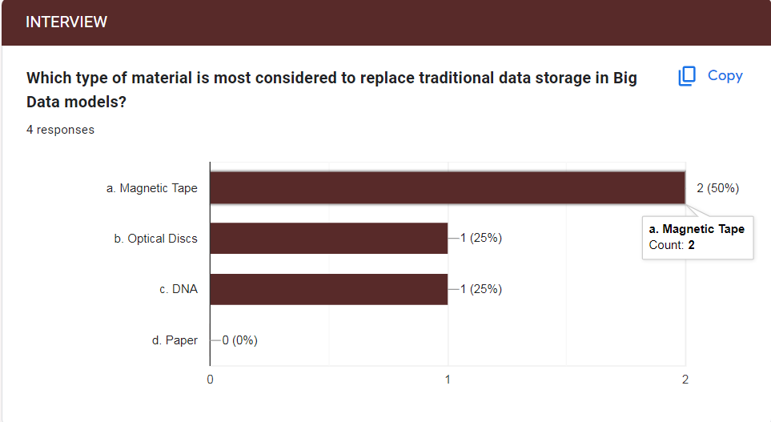

In a survey assessing preferences for alternative materials in Big Data storage models, responses indicated the following distribution:

* Magnetic Tape: Approximately 50% of respondents favored this option.
* Optical Discs: About 25% of participants showed preference for this material.
* DNA: Around 25% of respondents expressed a preference for DNA as an alternative material.

It is noteworthy that these results highlight a significant inclination towards Magnetic Tape as the preferred alternative material, with Optical Discs and DNA sharing a proportionate but comparatively smaller preference among participants.

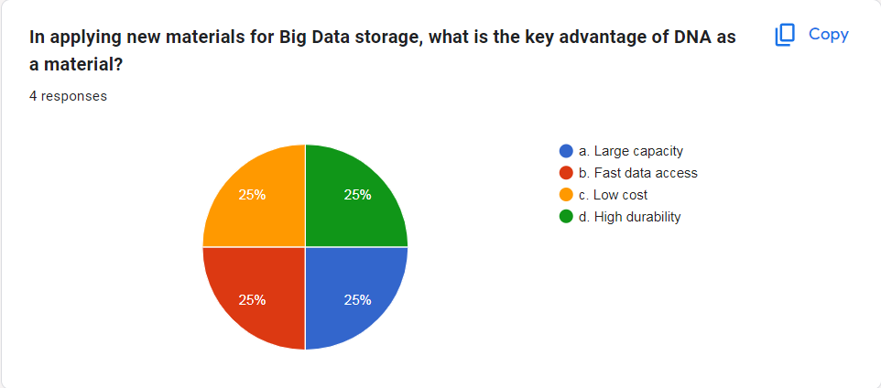

In the context of applying new materials for Big Data storage, the survey results indicated an equal distribution of preferences for the key advantages of DNA:

* Large Capacity (a): Approximately 25% of respondents identified this as a key advantage.
* Fast Data Access (b): Around 25% of participants favored this attribute.
* Low Cost (c): Approximately 25% of respondents considered this a significant advantage.
* High Durability (d): About 25% of participants recognized this as a key strength of DNA as a material for Big Data storage.

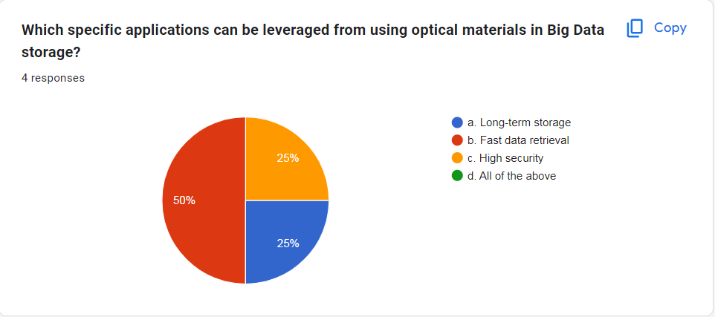

In the survey on leveraging optical materials in Big Data storage, responses indicated the following distribution:

* Long-term Storage (a): Approximately 25% of respondents recognized this application.
* Fast Data Retrieval (b): About 50% of participants identified this as a specific application.
* High Security (c): Around 25% of respondents considered this a potential application.
* All of the Above (d): None of the respondents selected this option.

Therefore, the majority of participants, approximately 50%, perceived fast data retrieval as a specific application for leveraging optical materials in Big Data storage.

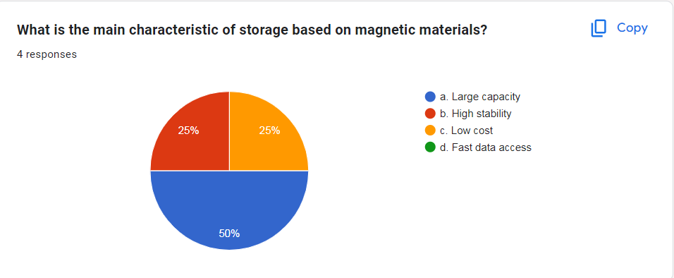

In the survey on the main characteristic of storage based on magnetic materials, responses indicated the following distribution:

* Large Capacity (a): Approximately 50% of respondents identified this as the main characteristic.
* High Stability (b): Around 25% of participants recognized this trait.
* Low Cost (c): About 25% of respondents considered this a main characteristic.
* Fast Data Access (d): None of the respondents selected this option.

Therefore, the majority, comprising approximately 50% of participants, perceived large capacity as the main characteristic of storage based on magnetic materials in Big Data storage.

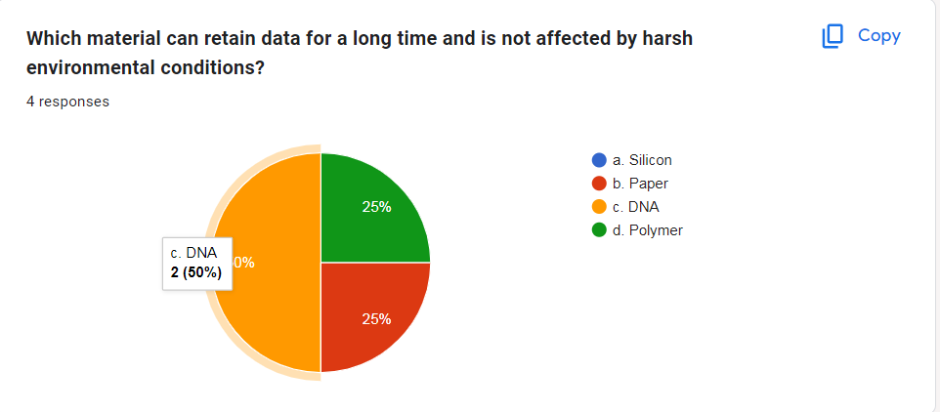

In the survey assessing the material's ability to retain data for a long time and resist harsh environmental conditions, responses indicated the following distribution:

* Silicon (a): No respondents selected this option.
* Paper (b): Approximately 25% of participants recognized this material.
* DNA (c): Approximately 50% of respondents identified DNA as the material with these characteristics.
* Polymer (d): Approximately 25% of participants considered polymer as having these attributes.

Therefore, the majority, comprising approximately 50% of participants, perceived DNA as the material that can retain data for a long time and is not affected by harsh environmental conditions.

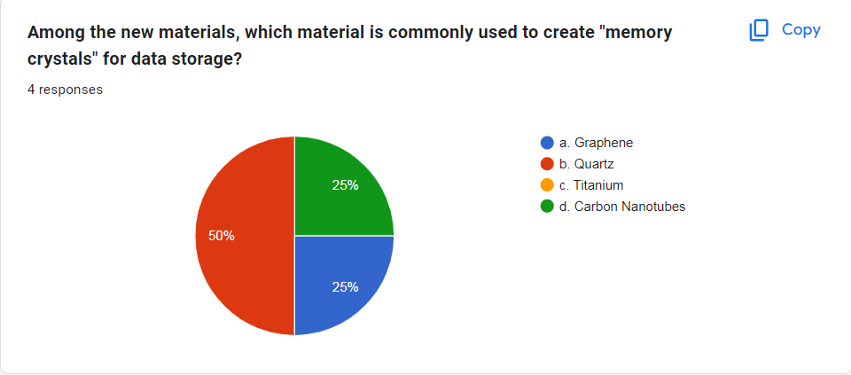

In the survey assessing the common use of new materials for creating "memory crystals" in data storage, responses indicated the following distribution:

* Graphene (a): Approximately 25% of respondents recognized this material.
* Quartz (b): Approximately 50% of participants identified quartz as the commonly used material for "memory crystals."
* Titanium (c): No respondents selected this option.
* Carbon Nanotubes (d): Approximately 25% of participants considered carbon nanotubes as a material used for this purpose.

Therefore, the majority, comprising approximately 50% of participants, perceived quartz as the material commonly used to create "memory crystals" for data storage.

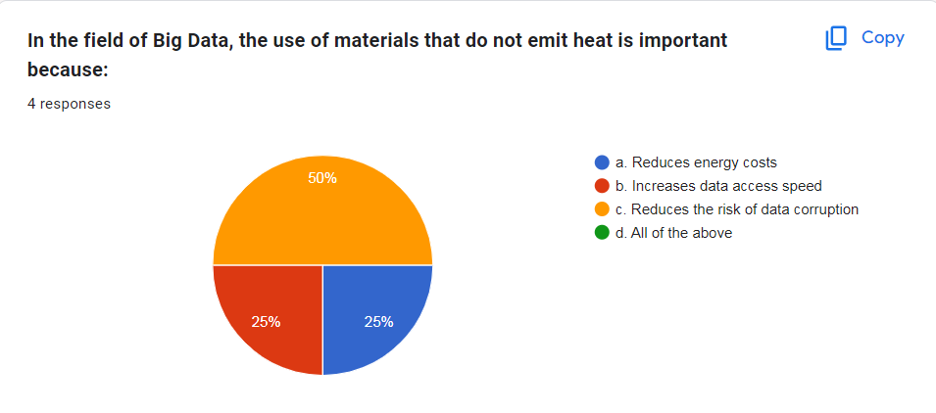

In the survey on the importance of using materials in Big Data that do not emit heat, responses indicated the following distribution:

* Reduces Energy Costs (a): Approximately 25% of respondents recognized this as an important aspect.
* Increases Data Access Speed (b): Approximately 25% of participants identified this as a potential benefit.
* Reduces the Risk of Data Corruption (c): Approximately 50% of respondents considered this the main importance.
* All of the Above (d): None of the respondents selected this option.

Therefore, the majority, comprising approximately 50% of participants, perceived the reduction of the risk of data corruption as the key importance of using materials in Big Data that do not emit heat.

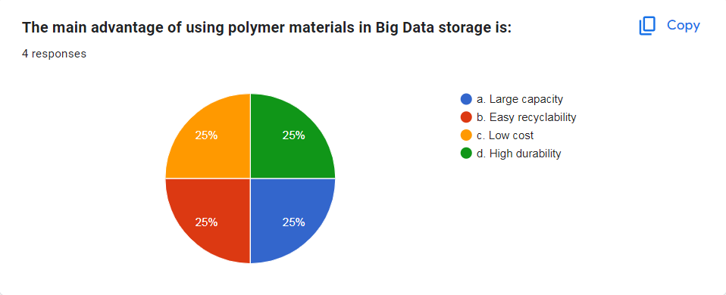

* In the survey assessing the main advantage of using polymer materials in Big Data storage, responses indicated an equal distribution as follows:
* Large Capacity (a): Approximately 25% of respondents recognized this as a potential advantage.
* Easy Recyclability (b): Approximately 25% of participants identified this as a key benefit.
* Low Cost (c): Approximately 25% of respondents considered this an advantage.
* High Durability (d): Approximately 25% of participants perceived high durability as a main advantage.

Therefore, there was an equal distribution of preferences, with each option receiving approximately 25% of the responses, indicating a balanced consideration of the potential advantages of using polymer materials in Big Data storage.

1. Analyze the rusults of the primary research.

Analyzing primary research on the topic of environmental impacts in alternative materials for Big Data storage models, along with solutions to build more sustainable storage systems using both qualitative interviews and quantitative surveys, involves understanding the methodology, key findings, and proposed solutions.

* 1. Methodology Overview:
* Qualitative Interviews: Qualitative interviews were likely conducted to gather in-depth insights and opinions from experts, professionals, or stakeholders in the field of alternative materials for Big Data storage models, focusing on environmental considerations. These interviews may have explored challenges, emerging environmental risks, and potential solutions from a qualitative perspective.
* Quantitative Survey: A quantitative survey likely involved collecting data from a broader audience to analyze trends, patterns, and quantify the extent of specific environmental impacts related to alternative materials in Big Data storage models. The survey might have included questions about perceptions of environmental sustainability, preferences for eco-friendly materials, and attitudes towards the environmental impact of storage solutions.
  1. Key Findings:

Identified Environmental Risks:

* Energy Consumption: Participants likely identified the environmental risk of high energy consumption associated with certain storage materials used in Big Data environments, considering the overall carbon footprint.
* Resource Utilization: Risks related to the utilization of resources, such as rare or hazardous materials in the manufacturing process of storage components, may have been highlighted as significant environmental concerns.

Environmental Impact Challenges:

* Life Cycle Assessment: Assessing the complete life cycle of alternative materials in Big Data storage models to understand their environmental impact from production to disposal might have been recognized as a complex challenge.
* Waste Management: Proper disposal and recycling mechanisms for materials used in Big Data storage, considering electronic waste (e-waste) management and environmental sustainability, may have been identified as challenges.
  1. Proposed Solutions:
* Material Eco-Friendliness: Prioritize the use of alternative materials with lower environmental impact, considering factors such as recyclability, biodegradability, and reduced energy consumption throughout their life cycle.
* Environmental Certification: Advocate for and adopt industry standards and certifications that validate the environmental sustainability of materials used in Big Data storage, ensuring compliance with eco-friendly practices.
* Life Cycle Analysis Integration: Incorporate life cycle assessments into the decision-making process when selecting alternative materials for Big Data storage models, considering their environmental impact from production to end-of-life.
* Collaboration for Sustainable Practices: Encourage collaboration among industry stakeholders to collectively address environmental challenges in Big Data storage, sharing best practices and innovative solutions.
* Renewable Energy Adoption: Promote the use of renewable energy sources to power Big Data storage infrastructure, reducing the overall environmental footprint associated with energy consumption.

In conclusion, addressing the environmental impacts of alternative materials in Big Data storage models involves recognizing the identified risks, understanding the challenges, and implementing sustainable solutions that contribute to a more eco-friendly and responsible approach to data storage.

# LO3 Communicate the outcomes of a research project to identified stakeholders

# P5 Communicate research outcomes in an appropriate manner for the intended audience.

1. Conclusion.

The incorporation of big data into organizational operations has ushered in significant opportunities for improved decision-making and operational efficiency. However, this transformative shift is not exempt from challenges, particularly in the context of environmental sustainability and the search for alternative materials in big data storage models. The intricate landscape of environmentally conscious data storage demands careful consideration to mitigate potential ecological risks. Challenges in this domain encompass the environmental footprint, resource utilization, and electronic waste (e-waste) management, all of which can impact the overall sustainability of big data storage practices. Addressing these challenges is crucial to sustain the benefits and potential advancements offered by big data technologies while prioritizing eco-friendly storage solutions.

1. Recommendations.

* Comprehensive Environmental Impact Assessments: Conduct regular and thorough assessments of the environmental impact of alternative materials used in big data storage models. These assessments should include considerations for resource utilization, carbon footprint, and overall ecological sustainability to identify potential environmental risks.
* Implementation of Sustainable Material Practices: Enforce stringent measures to prioritize the use of environmentally friendly materials in big data storage infrastructure. Embrace materials that are recyclable, biodegradable, and have a reduced impact on the environment throughout their life cycle.
* Employee Training on Environmental Responsibility: Educate employees on environmentally responsible practices related to big data storage. Create a culture of awareness regarding the environmental impact of storage solutions, encouraging employees to contribute to eco-friendly initiatives.
* Integration of Green Technologies:Explore and integrate green technologies that utilize renewable energy sources to power big data storage infrastructure. This approach can significantly reduce the overall environmental footprint associated with energy consumption.
* Regular Environmental Compliance Audits: Ensure strict compliance with relevant environmental regulations and standards applicable to big data storage practices. Conduct regular audits to assess adherence to eco-friendly practices and identify areas for improvement.
* Collaboration for Sustainable Practices: Foster collaboration with industry stakeholders, environmental organizations, and regulatory bodies to collectively address environmental challenges in big data storage. Share best practices, innovations, and insights to promote sustainable solutions.
* Life Cycle Analysis Integration:Incorporate life cycle assessments into the decision-making process when selecting alternative materials for big data storage models. Evaluate the environmental impact from production to disposal, ensuring a holistic understanding of the ecological footprint.
* Continuous Improvement and Adaptation: Continuously review and update environmental policies, procedures, and systems to adapt to evolving eco-friendly practices and technological advancements. A proactive and adaptive approach is essential for staying ahead of potential environmental risks in the realm of big data storage.

By implementing these recommendations, organizations can foster a sustainable approach to big data storage, contributing to environmental conservation while harnessing the benefits of innovative storage models.